CECS 326

Spring 2017

Haney Williams

Project 3

Phanna Chrin

Amanda Pan

**Given Problem:**

Write a program using C/C++ to do the following. The program creates three child processes with child

numbers k = 0, 1, 2. Each child process attempts to acquire/create a lock file lock in num_tries times.

After each try, if still not successful, the child process sleeps for a random mod (sleeptime). If successful, the child process displays contents of a text file text.dat (created by the user), removes the lock file, and then exits with a return value being equal to the least significant 8 bits of its process ID. If after num_tries times and the child process still cannot acquire/create the lock file, it displays “Unable to obtain lock file” and kills itself with a signal value equal to its child number k. The arguments for the parent program include the text.dat file name, num_tries, and sleeptime. The parent process should remove any leftover lock files that may have existed from previous invocations before forking the child processes. The parent program should wait for the child and displays “Wait on PID: childpid returns status of (status)” where status is the status of the return in hexadecimal format. Show output where all processes eventually gain access to the file.

Show another output where at least one process fails and displays “Unable to obtain lock file”.

**Problem Analysis:**

This project is to understand how to lock a file. The parent program calls the child program.

In the child program, if the process is a child, the acquire program is executed to attempt to lock the file. If not, it kills itself. The child program waits for the process to obtain the lock file for a number of times. If it hasn’t obtained it, it sleeps; after a specific amount of tries and it still hasn’t obtain the file, it prints out that it can’t obtain it and kills itself. Otherwise, print the content of the file. After that, the program waits for the file to be released by calling the release program. If successful, the program exits with with a return value being equal to the least significant 8 bits of its process ID.

**Program Flowchart:**

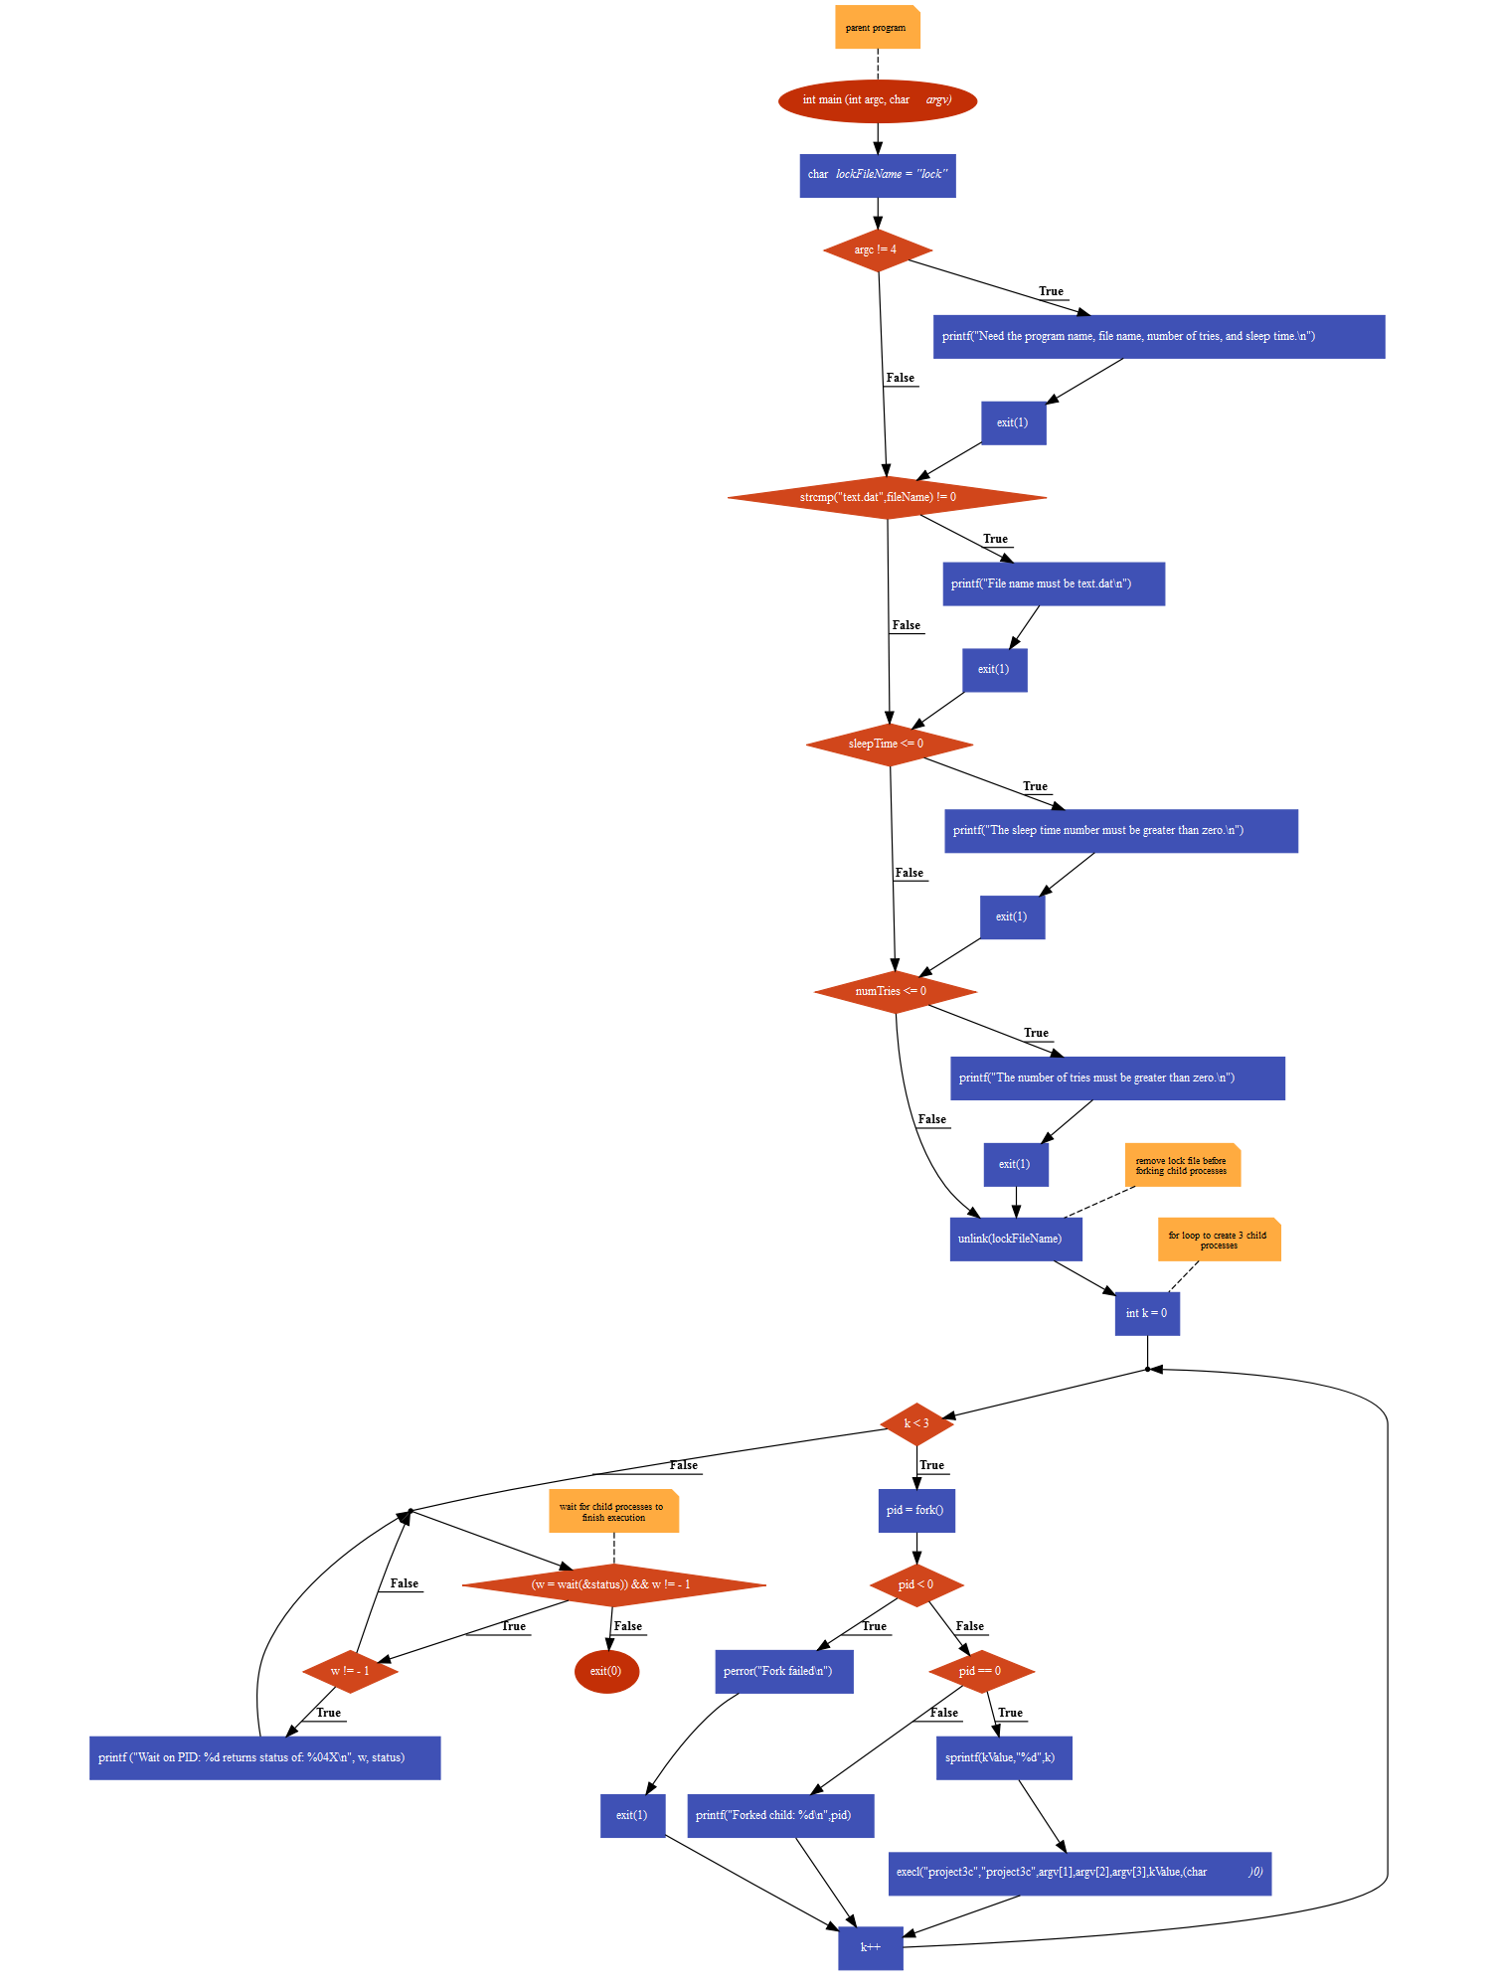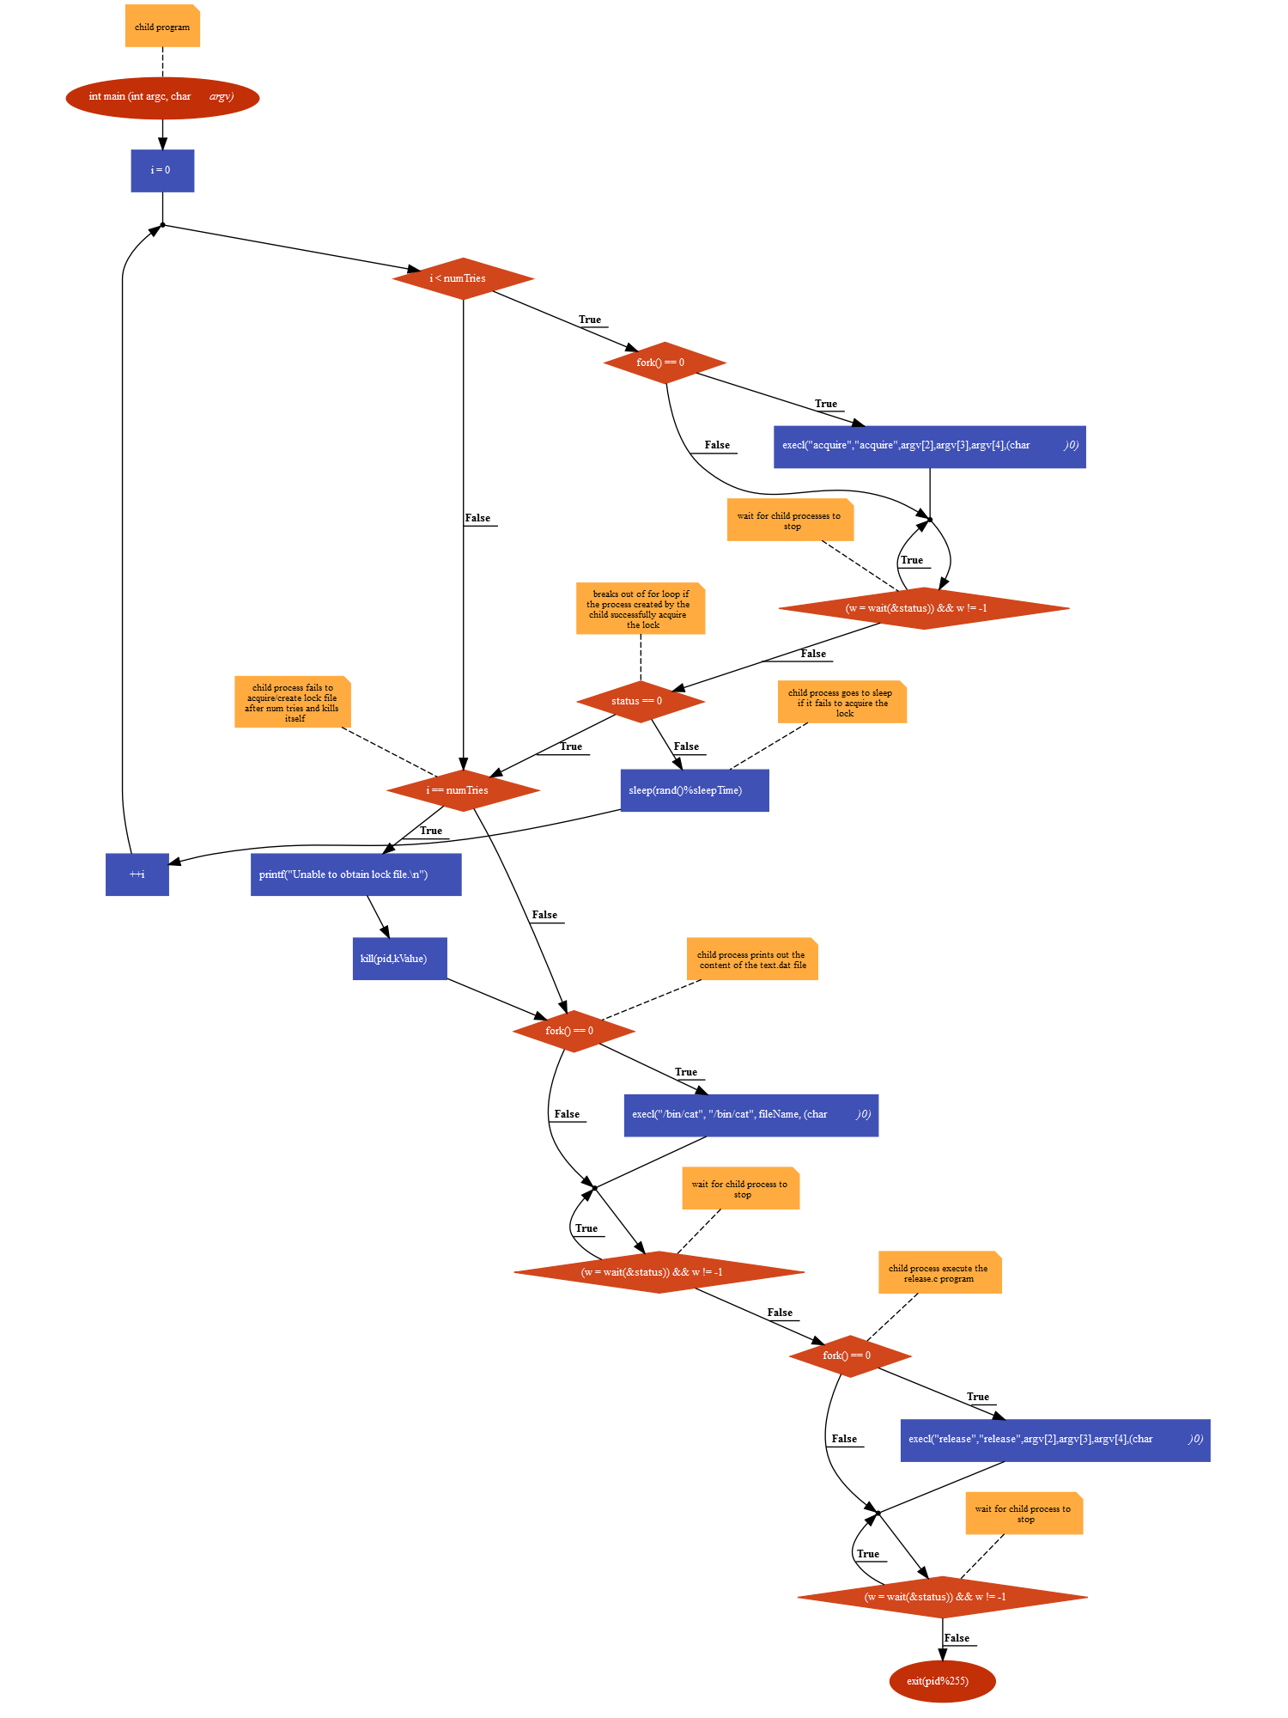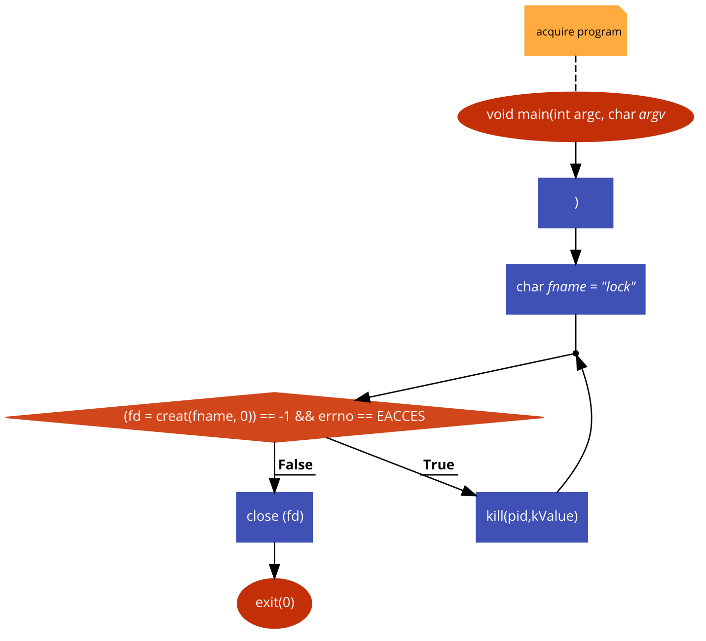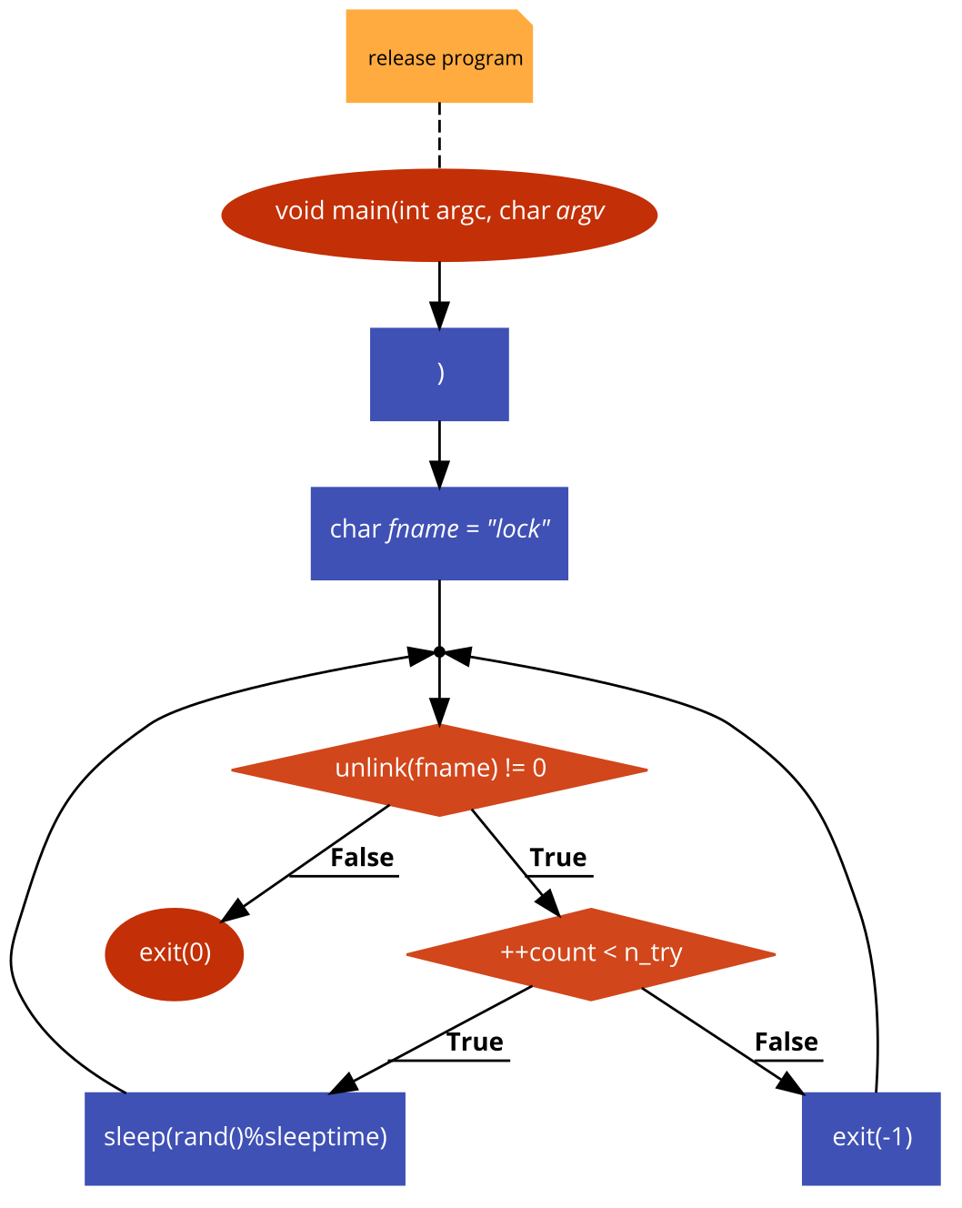

**C Code:**





**Output:**